Reconfigurable Test Fixture for Digital Integrated Circuits
Hardware Design Documentation
ABSTRACT
This report presents the design and implementation of a reconfigurable test fixture for evaluating 7400-series digital integrated circuits (ICs). The system enables dynamic signal routing, multi-voltage logic testing, and automated data acquisition through a USB-connected microcontroller platform. Key features include electrical isolation, programmable voltage references, multiplexed signal routing, and high-resolution analog-to-digital conversion. The design ensures accurate, flexible, and safe testing of digital ICs across a range of operating conditions.

I. INTRODUCTION
The increasing diversity of digital logic devices necessitates flexible testing platforms capable of supporting multiple voltage levels and configurations. Traditional fixed test setups lack adaptability and require significant manual intervention. This work presents a reconfigurable hardware system that enables testing of a varied number of digital ICs.

II. SYSTEM OVERVIEW:
The reconfigurable test fixture for digital integrated circuits is designed to evaluate and characterize 7400-series logic ICs across a range of operating voltage levels. The system provides a flexible platform that allows users to dynamically configure input signals, apply selectable voltage levels, and measure output responses through a software-controlled interface.
The fixture connects to a host computer via USB, enabling both power delivery and communication. An onboard microcontroller coordinates signal routing, voltage selection, and data acquisition while interfacing with external components such as analog switch arrays, multiplexers, and an analog-to-digital converter (ADC). The system supports multiple logic voltage levels (1.8V to 5V), allowing compatibility with a wide variety of digital devices.
By integrating electrical isolation, programmable signal routing, and high-impedance measurement capability, the design ensures safe operation, minimizes noise interference, and provides accurate testing results. This makes the system suitable for both educational use and practical validation of digital IC functionality.

III. SYSTEM ARCHITECTURE:
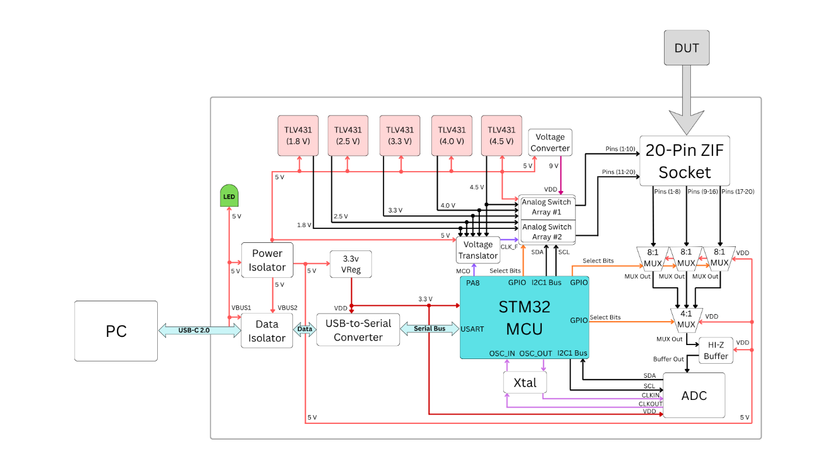
Fig. 1. Block Diagram of the Reconfigurable Test Fixture
In Figure 1 above, the IC test fixture connects to a user-end PC through a USB-C 2.0 connection, which provides 5 V and data for both power and communication. The 5 V from USB connects to a power indicator LED and, along with the data lines, is routed to individual isolators for protection. The isolated data then connects to a USB-to-Serial converter before interfacing with the STM32 microcontroller. The isolated 5 V rail powers multiple components, including a 3.3 V voltage regulator, buffer op-amp, 8:1 and 4:1 multiplexers, a voltage translator, and a voltage converter, as well as multiple voltage reference circuits (1.8 V, 2.5 V, 3.3 V, 4.0 V, and 4.5 V) made up of TLV431. TLV431 are shunt regulators and used to maintain a stable voltage signal by using voltage dividing resistors. The 3.3 V regulator supplies power to the USB-to-Serial converter, STM32 microcontroller, and the analog-to-digital converter. The voltage converter generates 9 V to power the analog switch arrays, which provide routing to all 20 pins of the zero-insertion force (ZIF) socket to accommodate the input pin requirements of a valid 7400 series IC for testing. The 20-pin ZIF socket provides connection access for these ICs, supporting a maximum of 20 pins. A cascade of three 8:1 multiplexers provides routing to all 20 pins of the ZIF socket to accommodate output pins of the IC under test and funnels them into a 4:1 multiplexer. The 4:1 multiplexer sends the selected signal through a buffer op-amp to allow for high-impedance (Hi-Z) testing, after which the buffer op-amp drives the signal into the analog-to-digital converter for conversion. The analog-to-digital converter then sends the digitized signal to the STM32 microcontroller for analysis. The STM32 processes the received data and transmits the results back to the user-end PC. Additionally, the STM32 controls multiple components through select bits, including the analog switch arrays and both the 8:1 and 4:1 multiplexers, to determine signal pathing during testing. A voltage translator is used to match voltage levels for clock rise and fall signals required by certain ICs, and an external crystal (Xtal) provides a higher frequency (24 MHz) and improved accuracy for both the STM32 and the analog-to-digital converter.

IV. REQUIREMENTS AND SPECIFICATIONS
A. Functional Requirements
- Support up to 20-pin 7400-series ICs
- Provide configurable voltage levels (1.8V–5V)
- Enable dynamic signal routing
- Measure and report logic states
B. Electrical Specifications
- Input Voltage: 5V (USB)
- ADC Resolution: 24-bit
- Logic Levels: 1.8V–5V

V. DESIGN DECISIONS
The purpose of this test fixture is to provide a flexible and safe platform capable of testing a wide range of logic voltage levels for 7400-series integrated circuits. Several key design decisions were made to achieve this functionality:
USB-Based Power and Communication
USB-C was selected as the primary interface due to its widespread availability and ability to provide both power and data through a single connection. Operating in USB 2.0 mode simplifies implementation while still meeting system bandwidth requirements.
Electrical Isolation
Isolation was implemented using the ADuM4160 and UCC33420 to protect the host computer and eliminate ground loops. This improves measurement accuracy and prevents noise from propagating between the host and the test circuitry.
Microcontroller Selection (STM32)
The STM32 microcontroller was chosen for its balance of processing capability, peripheral support, and ease of integration. It provides sufficient GPIO, I²C, and UART interfaces to control multiplexers, switch arrays, and communication modules while maintaining low power consumption.
External ADC Usage
An external ADC (NAU7802) was used instead of the internal STM32 ADC to achieve higher resolution and improved measurement accuracy. This is particularly important when detecting small voltage differences and high-impedance states.
Multiplexing and Switching Architecture
Instead of dedicating a measurement channel to each pin, multiplexers (8:1 and 4:1) and an analog switch array (ADG2128) were used to reduce hardware complexity while maintaining flexibility. This allows a single ADC channel to measure multiple signals efficiently.
Multi-Voltage Support
Multiple voltage references (1.8V to 5V) were implemented using TLV431 shunt regulators. This enables the system to test ICs operating at different logic levels and ensures stable and accurate voltage generation.

High-Impedance Measurement Capability
A buffer op-amp stage was included before the ADC to allow high-impedance (Hi-Z) measurements. This prevents loading effects and ensures accurate detection of open or disconnected signals.
Dedicated Power Domains
Separate isolated and non-isolated domains were used to improve signal integrity and system reliability. Sensitive analog and measurement circuits operate in the isolated domain to minimize noise.

VI. SIGNAL FLOW DESCRIPTION
The system operates through a coordinated signal flow controlled by the STM32 microcontroller:
- A command is sent from the user’s PC to the system via the USB interface.
- The USB-to-UART bridge (CP2102) converts the incoming USB data into serial communication for the STM32.
- The STM32 processes the command and configures the analog switch array and multiplexers to establish the desired signal path.
- Selected voltage levels are applied to the input pins of the device under test (DUT) through the switch matrix.
- Output signals from the DUT are routed through a cascade of multiplexers (8:1 followed by 4:1).
- The selected signal passes through a high-impedance buffer stage to prevent loading.
- The buffered signal is sent to the ADC, where it is converted into digital data.
- The STM32 reads the ADC data via I²C, processes the results, and determines the logic state or measurement outcome.
- The processed data is transmitted back to the PC for display and analysis.
This structured signal flow enables flexible, automated, and accurate testing of digital ICs.

VII. KEY COMPONENT SUMMARY TABLE
Component | Part Number | Function
Microcontroller | STM32 | Controls system operation and data processing
USB-to-UART Bridge | CP2102 | Enables communication between PC and MCU
USB Isolator | ADuM4160 | Provides data isolation between host and system
Power Isolator | UCC33420 | Generates isolated 5V supply
ADC | NAU7802 | Converts analog signals to digital data
Analog Switch Array | ADG2128 | Routes signals dynamically
Multiplexer (8:1) | ADG708 | Selects one of multiple input signals
Multiplexer (4:1) | ADG708 | Final signal selection stage
Voltage Reference | TLV431 | Generates stable reference voltages
Voltage Regulator | LDO (3.3V) | Supplies regulated power to digital components

VIII. SCHEMATICS
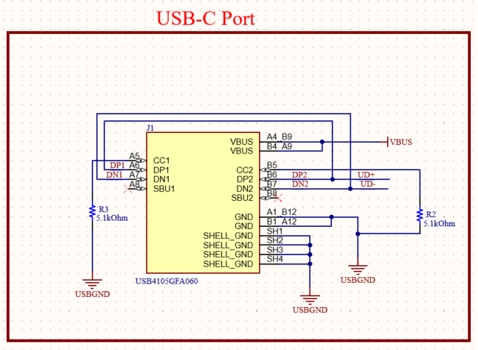
Figure 2. USB-C Port Schematic.
A USB-C connector is configured to operate in USB 2.0 mode, providing both power and data communication between the user and the board. The differential data lines (D+ and D−) are formed by tying DP1 with DP2 and DN1 with DN2, ensuring proper operation regardless of cable orientation.
The CC1 and CC2 pins are connected to 5.1 kΩ pull-down resistors, indicating that the device operates as a USB sink. This configuration allows the host to detect the connection and supply 5V (VBUS) power while enabling data communication.

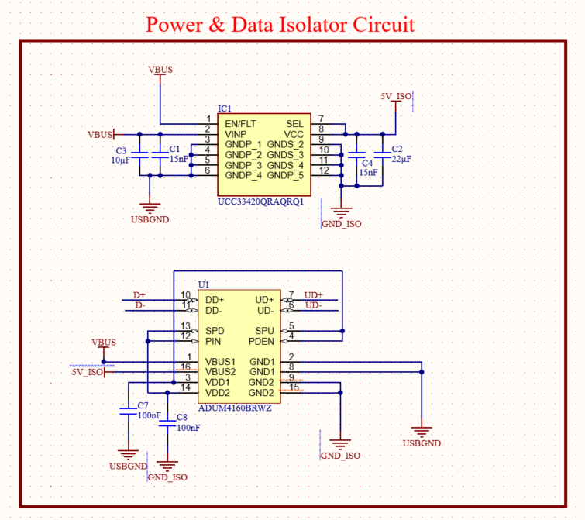
Figure 3. Power and Data Isolator Circuit
This circuit implements full USB isolation by separating both power and data between the host (computer) and the system. The top portion of the schematic uses the UCC33420 to convert the incoming USB VBUS (5V) into an isolated 5V supply (5V_ISO), effectively separating the host ground (USBGND) from the system ground (GND_ISO). This ensures that the board operates on a clean, isolated power domain, reducing noise and preventing ground loops. The bottom portion of the circuit uses the ADuM4160 USB isolator to transfer the differential data signals (D+ and D−) across the isolation barrier. On the host side, the data lines are received and magnetically coupled across the isolator, then reconstructed on the device side as DATA_P and DATA_N. Together, these components create two independent domains, host and system, allowing safe and reliable communication while protecting sensitive circuitry and improving measurement accuracy by minimizing noise interference.

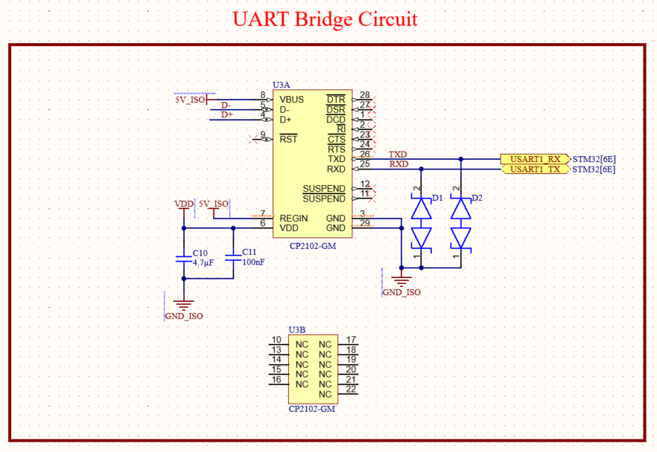
Figure 4. USB-to UART Bridge
This circuit implements a USB-to-UART communication bridge using the CP2102, enabling communication between the host computer and the microcontroller. The differential USB data lines (D+ and D−), labeled as DATA_P and DATA_N, enter from the isolated USB domain (5V_ISO and GND_ISO) and connect to the CP2102, which converts USB signals into UART signals. The device is powered using the isolated 5V supply, with local decoupling capacitors (4.7 µF and 100 nF) ensuring stable operation. On the output side, the CP2102 provides TXD and RXD signals, which are routed to the microcontroller’s UART interface (USART1 TX/RX). ESD protection diodes are placed on the UART lines to protect against voltage spikes and improve system robustness. Overall, this circuit enables reliable, isolated serial communication between the USB host and the onboard microcontroller while maintaining signal integrity and protection.

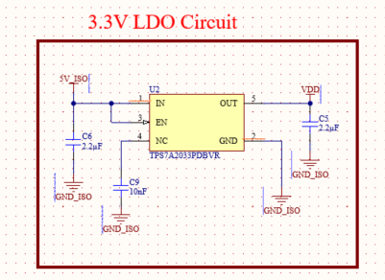
Figure 5. 3.3V LDO Circuit.
This circuit implements a 3.3V low-dropout (LDO) regulator to generate a stable supply voltage for low-power components on the board. The regulator takes the isolated 5V supply (5V_ISO) as its input and steps it down to a regulated 3.3V output (VDD). Input and output capacitors (2.2 µF) are used to stabilize the voltage and reduce noise, while an additional 10 nF capacitor on the enable pin helps filter any unwanted transients. The entire circuit is referenced to the isolated ground (GND_ISO), maintaining consistency with the system’s isolated power domain. This ensures a clean and reliable 3.3V rail for sensitive digital and analog components, contributing to overall system stability and performance.
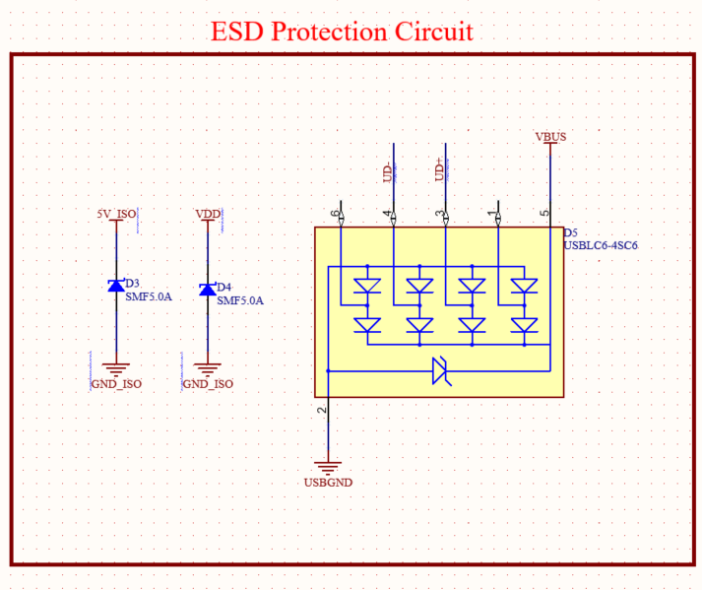
Figure 6. ESD Protection Circuit
This circuit provides electrostatic discharge (ESD) protection for the USB interface and critical signal lines. Transient voltage suppression (TVS) diodes are placed on key lines, including VBUS, TX, and RX, to protect against voltage spikes caused by electrostatic events or external disturbances. The USBLC6-4SC6 device is used to protect the USB data lines (D+ and D−) by clamping high-voltage transients safely to ground (USBGND), ensuring the integrity of the communication interface. Additional TVS diodes (SMF5.0A) are used on power and signal lines referenced to the isolated ground (GND_ISO), providing localized protection within the system. This design helps prevent damage to sensitive components, improves system robustness, and ensures reliable operation in environments where ESD events may occur.

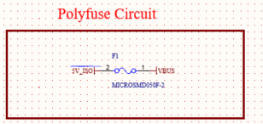
Figure 7. Polyfuse Circuit
This circuit implements overcurrent protection using a resettable polyfuse (PTC fuse) on the 5V supply line. The polyfuse is placed between the isolated 5V supply (5V_ISO) and the downstream VBUS rail, allowing normal current flow during standard operation. If excessive current is drawn due to a fault or short circuit, the polyfuse increases its resistance significantly, limiting the current and protecting the rest of the system. Once the fault is removed, the polyfuse automatically resets to its low-resistance state, restoring normal operation without requiring replacement. This provides a simple and reliable method of protecting the power path from damage.

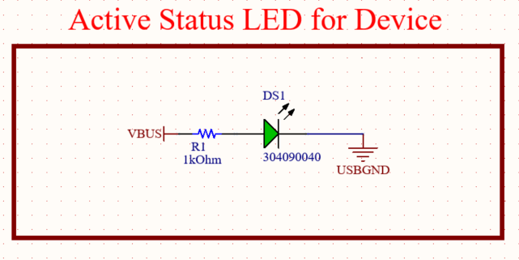
Figure 8. Active Status LED for Device
This circuit implements a simple status indicator using an LED to show when the device is powered. The LED is connected to the VBUS line through a current-limiting resistor, allowing it to illuminate whenever USB power is present. The resistor ensures that the LED operates within a safe current range, preventing damage while providing visible indication. The LED is referenced to USB ground (USBGND), making it active as soon as the USB cable is connected. This provides a quick and intuitive visual confirmation that the device is receiving power.

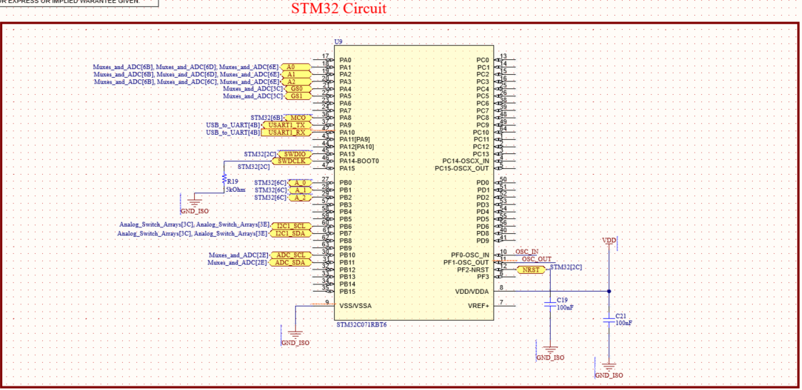
Figure 9. STM32 Circuit
This circuit implements the STM32 microcontroller as the central control unit of the system, responsible for coordinating data acquisition, processing, and communication. The microcontroller interfaces with multiple subsystems, including the USB-to-UART bridge for communication, the ADC for measurement data, and external circuitry through GPIO pins. Power is supplied through the 3.3V rail (VDD), with local decoupling capacitors placed near the supply pins to ensure stable operation and reduce noise. The reset (NRST) and oscillator (OSC_IN/OSC_OUT) pins are configured to support reliable startup and clock generation. Additionally, communication interfaces such as I²C (SCL/SDA) and UART (TX/RX) are connected to enable interaction with peripheral devices and sensors. Overall, the STM32 serves as the core processing element, managing system logic, data flow, and control functionality.

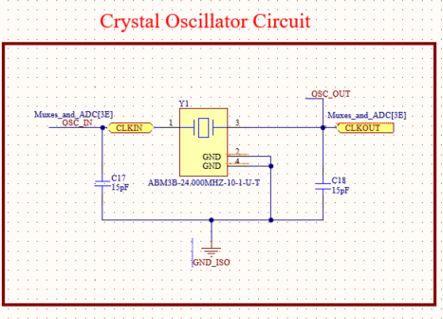
Figure 10. Crystal Oscillator Circuit
This circuit implements a crystal oscillator to provide a stable clock signal for the system. The 24 MHz crystal (ABM3B series) is connected between the microcontroller’s oscillator input (OSC_IN) and output (OSC_OUT) pins, forming a feedback loop required for oscillation. Two load capacitors (15 pF each) are connected from each side of the crystal to ground (GND_ISO) to stabilize the oscillation frequency and ensure reliable startup. The crystal generates a precise and stable clock signal (CLKIN/CLKOUT), which is essential for accurate timing, communication, and overall system operation.

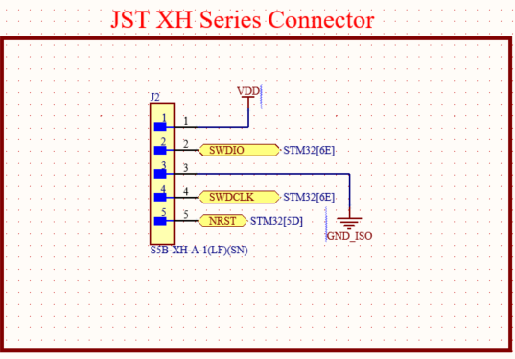
Figure 11. JST XH Series Connector
This circuit implements a JST XH series connector to provide an external programming and debugging interface for the STM32 microcontroller. The connector exposes key signals, including SWDIO and SWCLK for Serial Wire Debug (SWD) communication, as well as NRST for resetting the microcontroller. A 3.3V supply (VDD) and ground (GND_ISO) are also included to power the debugger and establish a common reference. This interface allows for firmware programming, real-time debugging, and system testing, making it an essential tool for development and troubleshooting.

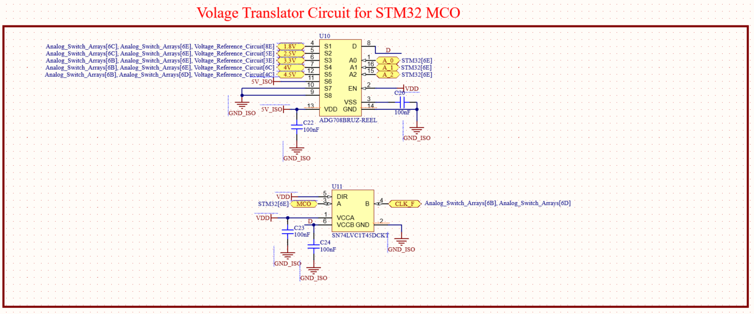
Figure 12. Voltage Translator Circuit for STM32 MCO
This circuit implements voltage translation and selection to ensure compatibility between the STM32 and devices under test (DUT) operating at different logic levels. An 8:1 multiplexer is used to select from multiple reference voltages (e.g., 1.8V, 2.5V, 3.3V, 4V, 4.5V, and 5V) generated by the voltage reference circuit, allowing the system to dynamically choose the appropriate logic level for the DUT. In addition, a 74LVC series level translator is used to shift the STM32’s MCO (microcontroller clock output) signal from its native 3.3V domain to the selected voltage level, ensuring proper signal compatibility. Together, this circuit enables flexible, multi-voltage operation and reliable interfacing with a wide range of logic devices.

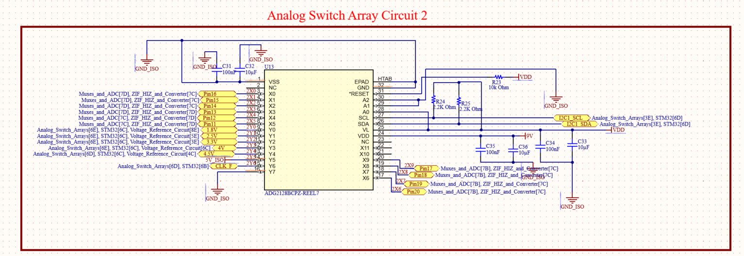
Figure 13. Analog Switch Array Circuit
This circuit implements an analog switch array that enables flexible routing of multiple voltage levels and signals throughout the system. The ADG2128 switch matrix allows different input voltages, including 1.8V, 2.5V, 3.3V, 4V, 4.5V, and 5V, as well as clock and measurement signals, to be selectively connected to various outputs under digital control. The device is controlled via an I²C interface (SCL and SDA) from the STM32, allowing dynamic configuration of signal paths in real time. Pull-up resistors are used on the I²C lines to ensure proper communication, and decoupling capacitors are included to stabilize the power supply. This design enables reconfigurable signal routing, allowing the system to adapt to different testing conditions and voltage requirements efficiently.

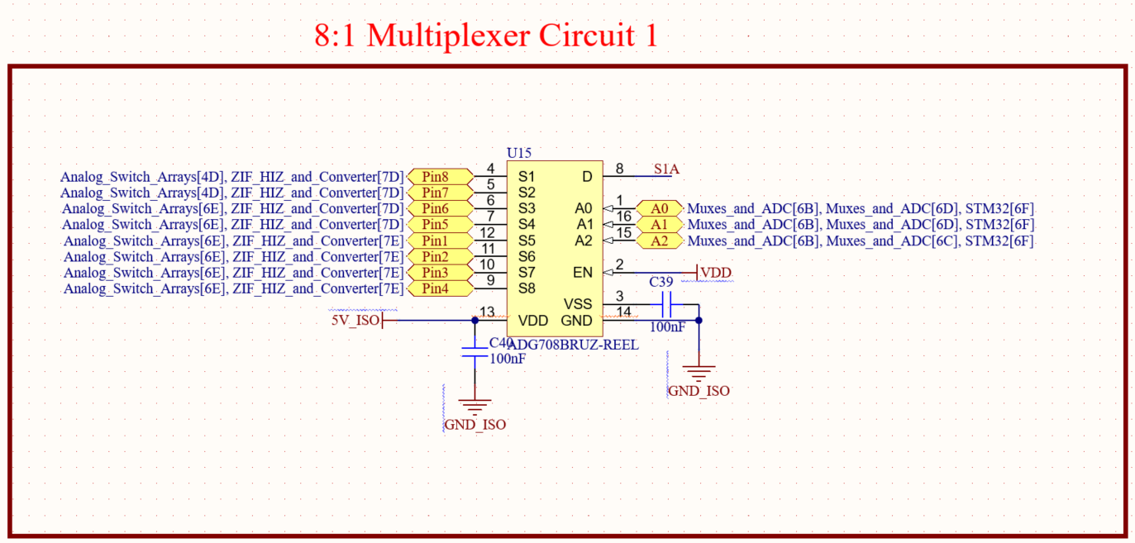
Figure 14. 8:1 Multiplexer Circuit
This circuit implements an 8:1 multiplexer that allows the system to select one of multiple input signals and route it to a single output. The ADG708 multiplexer receives several input signals, including outputs from the analog switch array and measurement circuitry, and selects one based on the control signals (A0, A1, A2) provided by the STM32. This enables dynamic signal selection and efficient use of a single ADC channel for multiple inputs. The device is powered from the isolated supply (5V_ISO) with a local decoupling capacitor to ensure stable operation. Overall, this circuit provides flexible signal routing and reduces the need for multiple ADC inputs by multiplexing several signals into one.

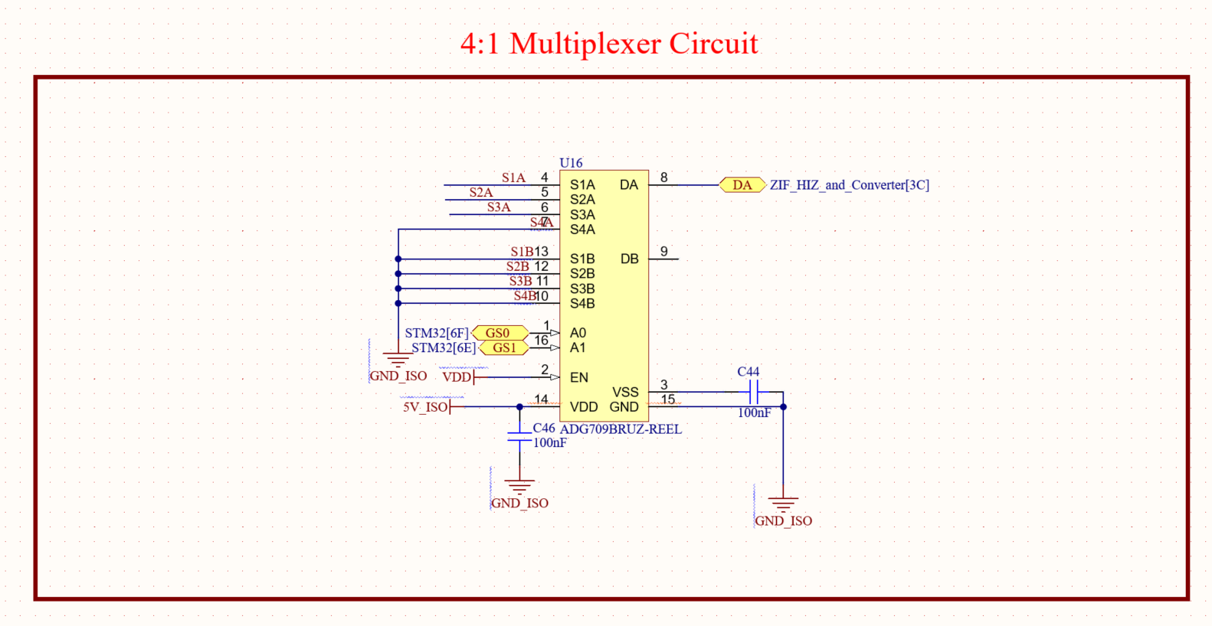
Figure 15. 4:1 Multiplexer Circuit
This circuit implements a 4:1 multiplexer that selects one of multiple input signals and routes it to a single output for further processing. The ADG708 device receives inputs from different signal paths and uses control lines (A0 and A1) from the STM32 to determine which input is passed to the output (DA). An enable (EN) pin allows the multiplexer to be activated or disabled as needed. The device is powered using the isolated 5V supply (5V_ISO), with a local decoupling capacitor to ensure stable operation. This configuration allows efficient signal selection and routing, enabling multiple signals to share a single processing path while maintaining system flexibility.

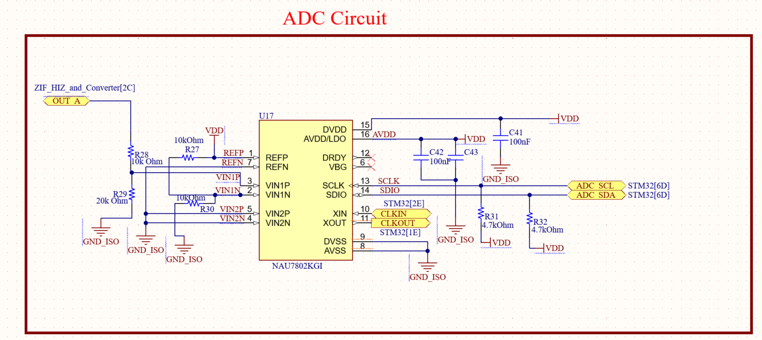
Figure 16. ADC Circuit
This circuit implements a high-resolution ADC stage using the NAU7802 to convert analog signals into digital data for processing by the microcontroller. A voltage divider network is incorporated at the input to scale down incoming signals, ensuring that the voltage presented to the ADC does not exceed the programmable gain amplifier (PGA) input limit of approximately 2.5V. This prevents signal clipping and allows the ADC to accurately measure higher input voltages without distortion. The conditioned signal is then applied to the differential input pins (VIN1P/VIN1N and VIN2P/VIN2N) for precise measurement. The ADC is powered by the 3.3V supply (VDD), with local decoupling capacitors used to minimize noise and maintain stability. Communication with the STM32 is handled through an I²C interface (SCL and SDA), with pull-up resistors ensuring proper signal levels. Overall, this design enables accurate, low-noise measurements while safely accommodating a wider input voltage range.

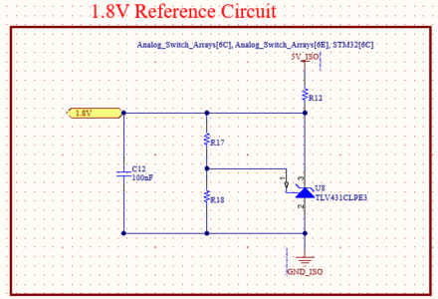
Figure 17. Voltage Reference Circuit for 1.8V
This schematic shows a set of precision reference voltage circuits that generate multiple stable voltage levels 1.8V, 2.5V, 3.3V, 4V, and 4.5V used throughout the system for accurate analog measurements and signal conditioning. Each reference circuit follows a similar design approach, where a resistor divider network is used to scale a higher supply voltage down to the desired level, and a precision reference device (TLV431) stabilizes the output. The resistor pairs are carefully selected to produce the target voltage, while the reference diode ensures that the output remains constant despite variations in supply voltage or load conditions and reducing current usage in the circuits as well.
In each circuit, capacitors are included to filter noise and improve stability, ensuring that the reference voltage remains clean and suitable for sensitive analog operations such as ADC conversions. The presence of these capacitors helps suppress high-frequency noise and prevents fluctuations that could degrade measurement accuracy. Some circuits also include additional resistors to provide proper biasing for the reference device, ensuring it operates within its optimal range.
These reference voltages are distributed to different parts of the system, such as the analog multiplexers and switch arrays, where precise voltage levels are critical for accurate signal interpretation. By generating multiple reference levels, the design allows flexibility in measuring signals across different ranges and improves the overall resolution and reliability of the system.

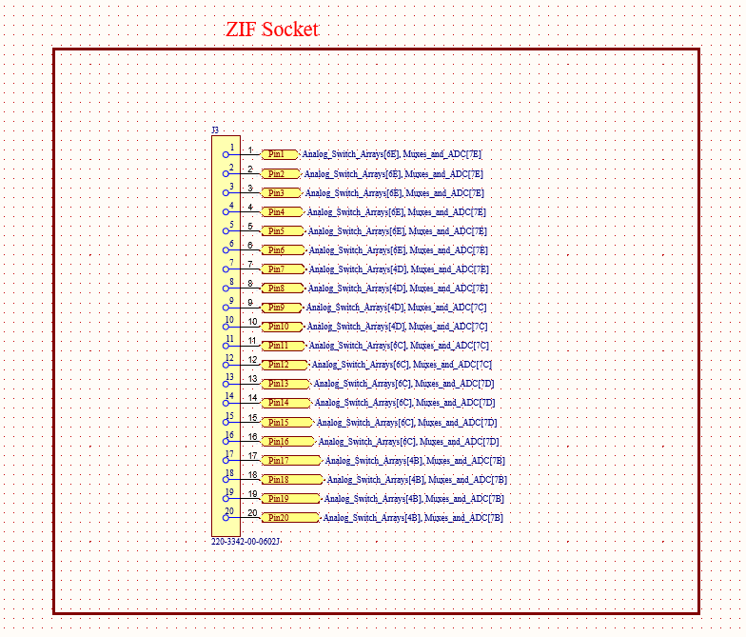
Figure 18. ZIF Socket
This schematic represents the external interfacing and signal conditioning portion of the system, consisting of a ZIF (Zero Insertion Force) socket, a voltage conversion circuit for the switch arrays, and a high-impedance buffer stage for the ADC. The ZIF socket serves as the primary interface for connecting the test components to the system. It exposes multiple analog signal lines, which are routed into the internal circuitry for measurement. These signals correspond to the various channels handled by the analog switch arrays and multiplexers, allowing the system to flexibly acquire data from many external sources while maintaining ease of connection and removal.

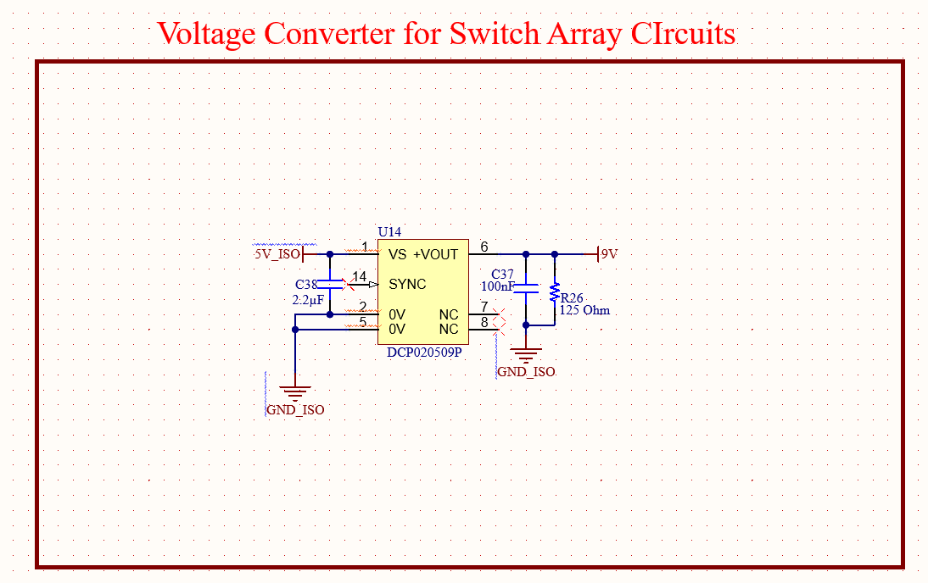
Figure 19. Voltage Converter for Switch Array Circuits
The voltage converter block provides a regulated supply specifically for the analog switch array circuits. This is implemented using a DC-DC converter to step-up the input voltage to a level suitable for the analog switches. Proper decoupling capacitors are included to ensure a stable output and minimize noise, which is critical for maintaining signal integrity in analog switching applications. Supplying a dedicated, clean voltage to the switch arrays helps reduce interference and ensures consistent switching behavior across all channels.

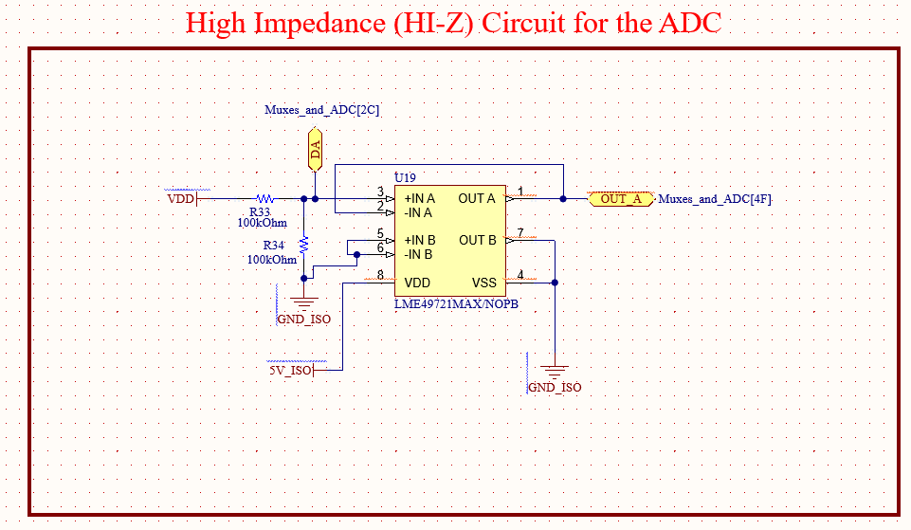
Figure 20. High Impedance Circuit for ADC
The high-impedance (Hi-Z) circuit is specifically designed to allow the ADC to measure a high-impedance condition, effectively representing an open circuit. This is achieved using an operational amplifier configuration that isolates the ADC input from the rest of the circuit, preventing loading effects and ensuring that minimal current is drawn from the measured node. By presenting a very high input impedance, this stage allows the system to accurately detect open or near-open conditions without influencing the signal itself. This is particularly important in measurement or diagnostic applications where distinguishing between connected and disconnected states is required.

IX. PCB LAYOUT
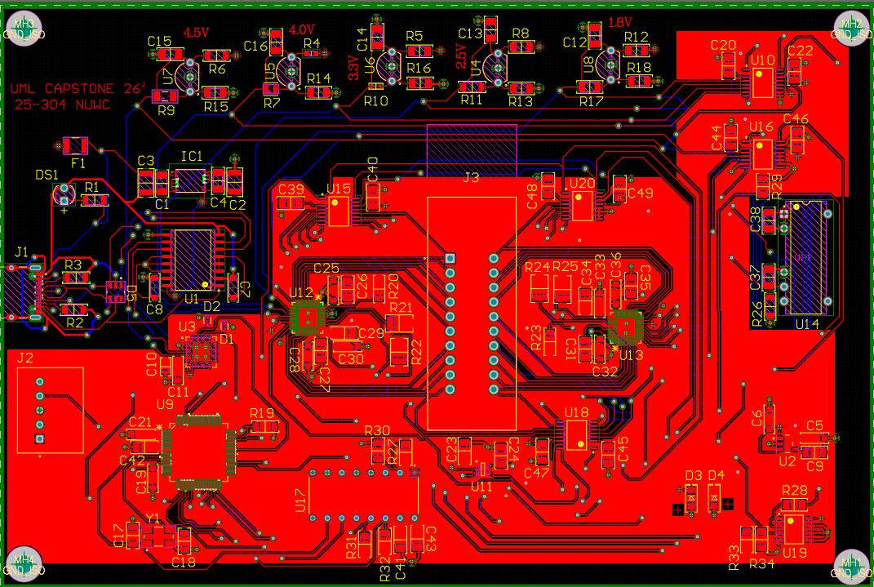
Figure 21. Top Layer 2D View of the PCB Layout

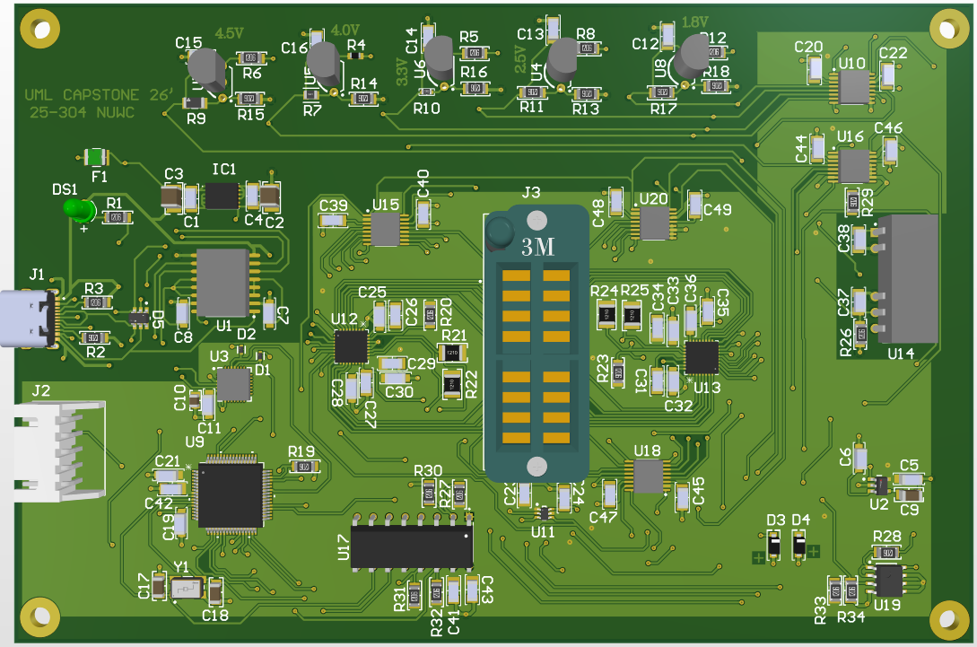
Figure 22. Top Layer 3D View of the PCB Layout

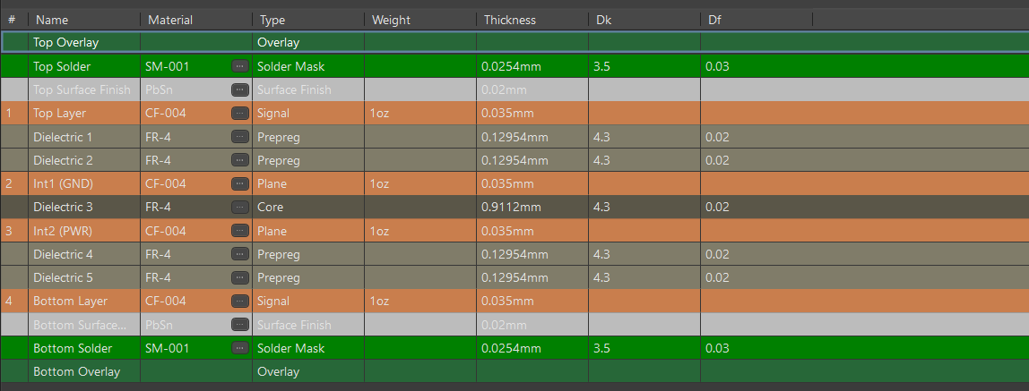
Figure 23. Layer Stack Setup of the board.

The PCB layout was designed to ensure signal integrity, minimize noise, and maintain clear separation between power domains. A multi-layer stackup was used, with dedicated ground and power planes to reduce impedance and improve stability.
Careful attention was given to routing sensitive analog signals, particularly those connected to the ADC, to minimize interference from digital switching noise. Short trace lengths and proper decoupling were used to improve measurement accuracy.
Differential USB data lines (D+ and D−) were routed as a matched pair to maintain signal integrity and comply with USB specifications. Ground planes were used extensively to provide shielding and reduce electromagnetic interference.
Power distribution was organized to separate the isolated and non-isolated domains, ensuring that noise from the host system does not affect measurement performance. Overall, the layout supports reliable operation and accurate signal acquisition.

X. LIMITATIONS
While the system provides significant flexibility, several limitations exist:
- The test fixture supports a maximum of 20 pins, limiting compatibility to specific IC packages.
- The ADC input range is constrained and requires voltage scaling for higher input signals.
- Analog multiplexing introduces switching delays, limiting high-speed signal analysis.
- USB 2.0 communication limits data transfer rates for high-throughput applications.
- The system is optimized for logic-level testing and is not suitable for high-frequency RF measurements.

XI. CONCLUSIONS
The reconfigurable test fixture presented in this work provides a flexible, accurate, and robust platform for evaluating 7400-series digital integrated circuits across a wide range of operating conditions. By integrating programmable signal routing, multi-level voltage references, and high-resolution analog-to-digital conversion, the system enables comprehensive testing of logic behavior while minimizing hardware complexity. The use of electrical isolation, ESD protection, and regulated power domains enhances system reliability and protects both the device under test and the host interface. Additionally, the incorporation of a microcontroller-based control architecture allows for automated configuration, data acquisition, and communication with a host PC, improving usability and scalability. Overall, the design successfully meets its intended objectives by combining adaptability, precision, and safety, making it suitable for both educational applications and practical digital IC validation environments.

XII. REFERENCES
[1] Global Connector Technology, “USB4105 USB Type-C Receptacle for USB 2.0, SMT Type, PCB Top Mount – Product Specification,” Rev. A1, Oct. 2019. [Online]. Available: USB4105 Datasheet
[2] Texas Instruments, “UCC33420 Ultra-Small, 1.5W, 5.0V, 3kVRMS Isolation Industrial DC/DC Module Datasheet,” Rev. E, Apr. 2025. [Online]. Available: UCC33420 Datasheet
[3] Analog Devices, “ADuM4160 Full/Low-Speed USB Digital Isolator Datasheet,” Rev. D, 2024. [Online]. Available: ADuM4160 Datasheet
[4] Silicon Laboratories, “CP2102C USB-to-UART Bridge Datasheet,” Rev. 1.6, 2023. [Online]. Available: https://www.silabs.com/documents/public/data-sheets/cp2102c-datasheet.pdf
[5] Littelfuse, “MICROSMD050F-2 Resettable PTC Fuse Datasheet,” 2022. [Online]. Available: https://www.littelfuse.com
[6] Texas Instruments, “TPS7A20 300-nA IQ, 300-mA Low-Dropout Regulator Datasheet,” Rev. H, 2024. [Online]. Available: https://www.ti.com/lit/ds/symlink/tps7a20.pdf
[7] STMicroelectronics, “USBLC6-4SC6 Low Capacitance ESD Protection for High-Speed Interfaces Datasheet,” Rev. 7, 2023. [Online]. Available: https://www.st.com/resource/en/datasheet/usblc6-4sc6.pdf
[8] Littelfuse, “SMF Series Surface Mount TVS Diodes Datasheet,” 2022. [Online]. Available: https://www.littelfuse.com/assetdocs/tvs-diodes-smf-datasheet
[9] STMicroelectronics, “STM32C071x8/xB Mainstream Arm Cortex-M0+ Microcontrollers Datasheet,” Rev. 5, 2024. [Online]. Available: https://www.st.com/resource/en/datasheet/stm32c071c8.pdf
[10] Analog Devices, “ADG708/ADG709 8:1/4:1 Analog Multiplexers Datasheet,” Rev. E, 2023. [Online]. Available: https://www.analog.com/media/en/technical-documentation/data-sheets/ADG708_709.pdf
[11] Texas Instruments, “SN74LVC1T45 Single-Bit Dual-Supply Bus Transceiver Datasheet,” Rev. S, 2024. [Online]. Available: https://www.ti.com/lit/ds/symlink/sn74lvc1t45.pdf
[12] Abracon, “ABM3B SMD Crystal Oscillator Datasheet,” Rev. 2022. [Online]. Available: https://abracon.com/Resonators/abm3b.pdf
[13] JST, “XH Series Connector Datasheet,” Rev. 2021. [Online]. Available: https://www.jst-mfg.com/product/pdf/eng/eXH.pdf
[14] Analog Devices, “ADG2128 I²C CMOS 8 × 12 Analog Switch Array Datasheet,” Rev. E, 2023. [Online]. Available: https://www.analog.com/media/en/technical-documentation/data-sheets/adg2128.pdf
[15] Analog Devices, “ADG708/ADG709 8:1/4:1 Analog Multiplexers Datasheet,” Rev. E, 2023. [Online]. Available: https://www.analog.com/media/en/technical-documentation/data-sheets/ADG708_709.pdf
[16] Nuvoton Technology Corporation, “NAU7802 24-Bit Analog-to-Digital Converter Datasheet,” Rev. 2.6, 2021. [Online]. Available: https://www.nuvoton.com/export/resource-files/en-us--DS_NAU7802_DataSheet_EN_Rev2.6.pdf
[17] Texas Instruments, “TLV431 Low-Voltage Adjustable Precision Shunt Regulator Datasheet,” Rev. Z, Jun. 2024. [Online]. Available: https://www.ti.com/lit/ds/symlink/tlv431.pdf
[18] 3M, “3M™ DIP Sockets, 2.54 mm TS-0365 Series Datasheet,” 2010. [Online]. Available: https://multimedia.3m.com/mws/media/494546O/3mtm-dip-sockets-100-2-54-mm-ts0365.pdf
[19] Texas Instruments, “LME49721 High-Performance, Rail-to-Rail Input/Output Audio Operational Amplifier Datasheet,” Rev. C, Apr. 2013. [Online]. Available: https://www.ti.com/lit/ds/symlink/lme49721.pdf

